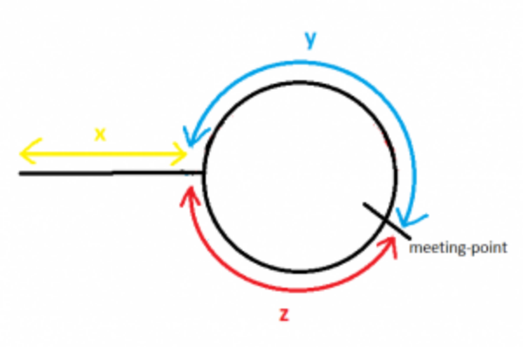
Distance travelled by slowPointer before meeting= x + y
Distance travelled by fastPointer before meeting = (x + y + z) + y
= x + 2y + z
Since fastPointer travels with double the speed of slowPointer, and time is constant for both when the reach the meeting point.
So by using simple speed, time and distance relation
2(x+y)= x+2y+z
=> x+2y+z = 2x+2y
=> x=z

Watch explanation:
https://www.youtube.com/watch?v=zbozWoMgKW0

